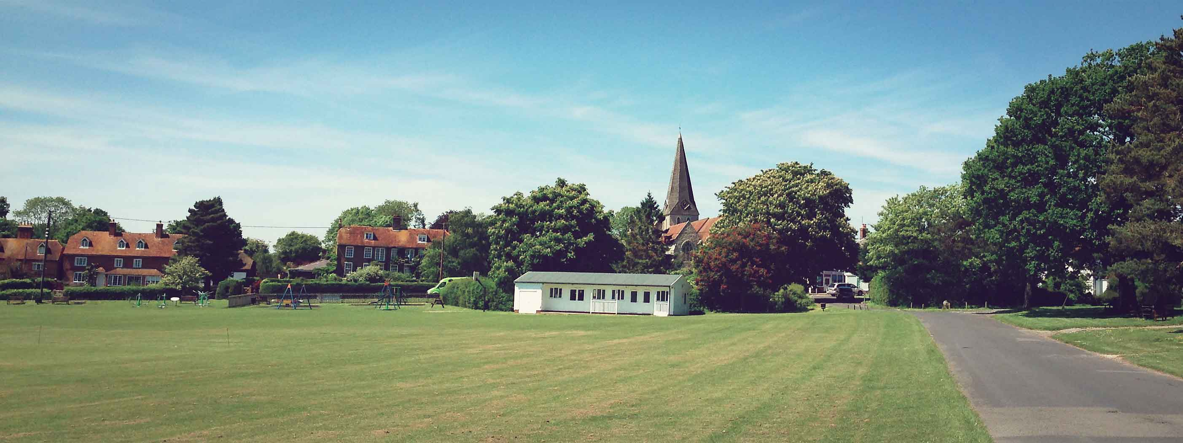

ALL RESIDENTS!!
YOU ARE INVITED TO ATTEND YOUR ANNUAL PARISH EVENT ON 18th APRIL at 7:00 pm
AT THE MEMORIAL HALL ANNEXE

This is your opportunity to make comment and discuss your Village Plan and view the results of the recent village survey.

SCHEDULE of SPEAKERS
Introduction by the Woodchurch Parish Council Chairperson, Lucy Quinn.
Review of the finances by the Clerk Ian Philo.
Presentation of the Woodchurch Village Plan by Councillor Rob Woods.
Questions and comments on the Village Plan or any matters concerning the Parish Council.
Woodchurch electors to be asked for thoughts and comments on the plan.

Light refreshments.
Copies of the Village Plan are available online and in The Hub.

